

Submitted By | Registration Number
Subject | AICT
Assignment | 03
Due Date | 31st December, 2024

Submitted to:
Lecturer | Engr. Hafiza Sundus

This assignment is mapped on CLO-4
Task 1 (05 marks)
Assignment Question: Flowchart for a Grocery Store Billing System
You are tasked with designing a grocery store billing system using functions. The system calculates the total bill based on items purchased, applies appropriate discounts based on the total amount, and returns the final amount. Your goal is to design a flowchart that represents the program’s logic using functions.
The program should be structured with functions for specific tasks:
- Function to calculate the total cost for a single item.
- Function to calculate the overall total for all items.
- Function to apply a discount based on the total amount.
- Function to print the final bill including the discount and total amount.
Grocery Store Billing System Requirements:
- Input:
  - The program will first receive the number of different items in the cart.
  - For each item, the program will receive:
    - The name of the item.
    - The price per unit of the item. ▪ The quantity of the item purchased.
- Processing:
  - The program should define the following functions:
      - Function 1: calculateItemTotal(price, quantity)
This function will calculate the total cost of an individual item:
Item Total = Price per Unit * Quantity
      - Function 2: calculateTotal(items)
This function will take all the items and calculate the total cost for all items in the cart by calling _{calculateItemTotal} for each item.
      - Function 3: applyDiscount(total)
This function will apply a discount based on the total:
      - If the total cost is greater than $200, apply a 10% discount.
      - If the total cost is between $101 and $200, apply a 5% discount. ▪ If the total cost is $100 or less, no discount will be applied.
      - Function 4: printBill(total, discount, finalAmount)
This function will print out the total before discount, the discount applied, and the final amount after applying the discount.
- Output:
  - The program will output:
    - The total cost before discount.
    - The discount applied.
    - The final amount after the discount is applied.

Output: Provide output screenshot here
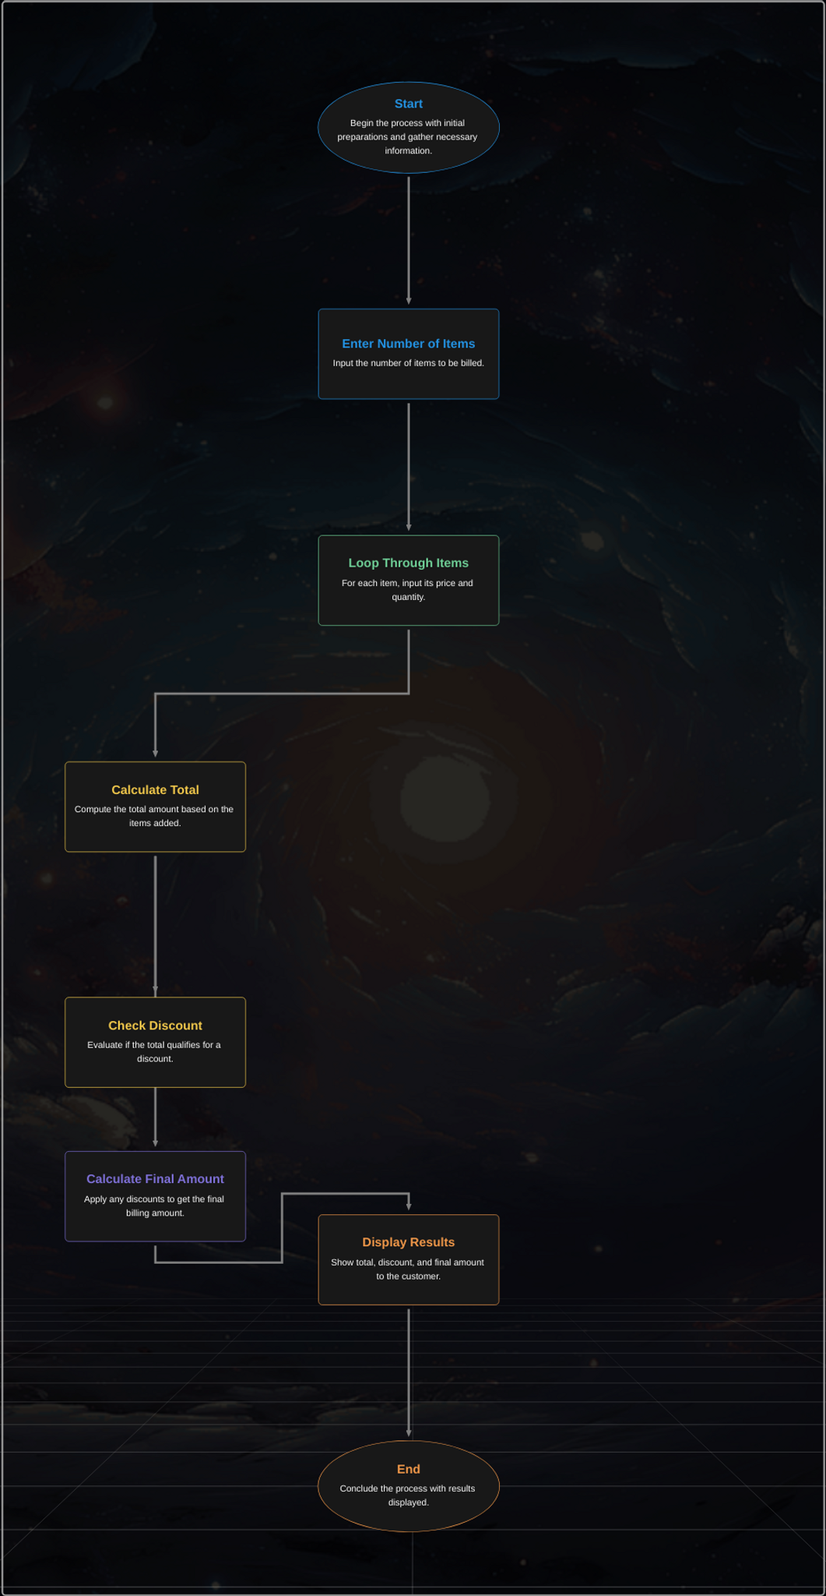
Task 2 (05 marks)
Problem Statement: Write a pseudo code that determines whether a given year _{Y} is a leap year or not. The program should take _{Y} as input and print "Leap Year" if it is a leap year and "Not a Leap Year" otherwise.
Expected Output:
• For example, if _{Y = 2020}, the output should be "Leap Year". If _{Y = 2021}, the output should be "Not a Leap Year".
Output:

Provide output screenshot here
